Perranarworthal Local History Group
A Walk in the North East – Bissoe and Greenwith
Steve Hartgroves, our Chairman, will be leading a walk around the north-eastern part of the parish on Sunday July the 13th.
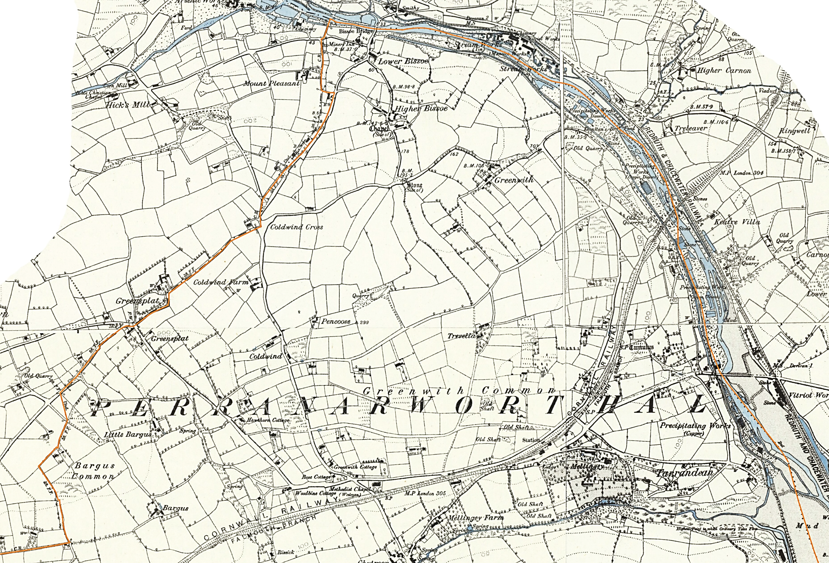
This area is surprisingly rich in medieval and industrial history and we’ll be exploring the old trackways through ancient field systems, visiting the medieval settlements of Bissoe and Greenwith, and taking in a section of the mineral tramway trail along the river valley.

We’ll meet in the car park at Dunstan’s Bridge, just north of the railway viaduct at 2:30.
The walk is about 2 miles (or 3km ) which at a leisurely pace will require about 2 hours.

